1.49: a) Let 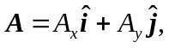 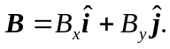
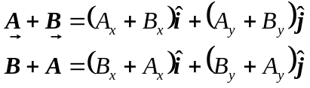

Scalar addition is commutative, so 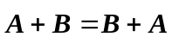

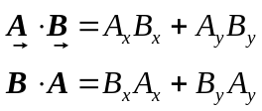

Scalar multiplication is commutative, so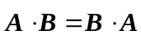

b)
Comparison of each component in each vector product shows that one is the negative of the other.

